Market Intelligence Research Brief -Technology M&A Integration
Student Name: Sandeep Sitaram
Date: 9/23/2026
Topic: Technology M&A Integration

1. Research Objective
Evaluate technology-sector mergers and acquisitions to identify the acquisition strategies, governance practices, leadership characteristics, and technology integration trends that most influence post-merger value creation and integration success. The research is intended to support executive decision-making related to acquisition planning, technology due diligence, integration strategy, risk mitigation, and long-term value realization.

2. Scope of Research
- Markets or industries covered: Technology sector mergers and acquisitions, including enterprise software, cloud computing, cybersecurity, telecommunications, networking, digital platforms, and internet-based technology companies. The analysis focuses on acquisition activity among major global technology organizations and the companies they acquired.
- Competitor types included: Large technology acquirers (e.g., enterprise software providers, cloud platform companies, telecommunications firms, networking companies, and digital platform providers), acquisition targets, and consulting firms influencing technology integration practices, including Accenture, Deloitte, PwC, IBM Consulting, KPMG, Cognizant, and TCS.
- Timeframe considered: Historical acquisition activity contained within the dataset combined with external market intelligence and technology integration trends from approximately 2020–2026 to provide current context for M&A and post-merger integration practices.
- Key constraints (e.g., limited research hours): Analysis is limited to the technology companies and acquisition transactions available in the dataset. The dataset does not directly measure post-merger integration outcomes or financial performance following acquisitions. Research was conducted using a limited allocation of Quick Research resources and publicly available market signals rather than proprietary consulting or investment banking data.
- Excluded from scope: Non-technology acquisitions, purely financial or arbitrage-driven transactions, consumer sentiment analysis, stock price forecasting, and industries not represented by the technology-focused acquisition dataset.

3. Research Approach
- Types of questions asked: Questions focused on acquisition patterns, characteristics of highly acquisitive technology companies, target company profiles, governance and leadership influences, technology integration trends, post-merger integration challenges, cloud modernization priorities, cybersecurity considerations, value-creation approaches, and factors associated with successful mergers and acquisitions.
- How research effort was prioritized: Research was conducted in two phases. First, internal analysis focuses on identifying acquisition activity trends, acquiring company characteristics, acquisition targets, and founder/board governance patterns using the uploaded datasets. Second, external research was prioritized around technology integration trends, post-merger risks, governance practices, and value-creation strategies to validate and enrich dataset findings. Research efforts were concentrated on signals most relevant to executive decision-making and post-merger integration success.
- Tools used within Amazon Quick Suite: Amazon Quick Suite Spaces were used to organize project assets and research outputs. A custom Market Intelligence Agent – Technology M&A Integration was created and configured with four internal knowledge sources (Acquiring Companies, Acquired Companies, Acquisitions, and Founders & Board Members datasets). Quick Research was used to gather external market intelligence and industry signals, and the AI agent was used to analyze, synthesize, validate, and produce executive-ready market intelligence findings.

4. Key Market Insights

Insight 1
Technology Leaders Use Acquisition-Led Innovation to Accelerate Growth
Insight Summary
Leading technology companies increasingly rely on acquisitions to acquire new capabilities, accelerate innovation, and expand product ecosystems rather than building every capability internally.
Supporting Evidence or Signals
- Analysis of the Technology Mergers & Acquisitions dataset identified 1,643 acquisition transactions involving 36 major technology companies.
- Cisco (162 acquisitions), Google (161 acquisitions), Microsoft, IBM, and Oracle were among the most active acquirers in the dataset.
- Quick Research findings indicated that serial acquirers often outperform peers by accelerating entry into emerging technology markets and reducing time-to-market for strategic capabilities.
Why This Insight Matters
Organizations pursuing growth through acquisition can rapidly expand technology portfolios and market reach; however, success depends on integration execution and governance discipline.

Insight 2
Governance and Leadership Involvement Are Common Characteristics of Highly Acquisitive Companies
Insight Summary
Technology firms that maintain active acquisition strategies often demonstrate strong founder influence or experienced board-level governance structures.
Supporting Evidence or Signals
- The dataset contains governance information for 36 technology companies and hundreds of founders, board members, and advisors.
- Companies such as Microsoft, Cisco, Google, Salesforce, Amazon, Apple, and IBM show extensive board oversight and governance participation within the Board Members dataset.
- External research consistently identifies executive alignment, governance structures, and decision-making accountability as major factors influencing integration success.
Why This Insight Matters
Acquisitions require major decisions around technology consolidation, workforce integration, and operating models. Governance structures help organizations realize synergies while reducing integration risk.

Insight 3
Cloud, Cybersecurity, and Enterprise Software Continue to Drive Technology Acquisition Activity
Insight Summary
Technology acquisitions increasingly focus on acquiring strategic capabilities in cloud platforms, cybersecurity, enterprise software, and digital infrastructure.
Supporting Evidence or Signals
- Review of the 1,610 acquired companies showed a strong concentration of software, infrastructure, enterprise technology, and digital platform organizations.
- External market research identified cloud modernization, cybersecurity resilience, identity management, and AI readiness as leading drivers of current technology M&A activity.
- Multiple Quick Research sources highlighted cloud and cybersecurity integration as top executive priorities following acquisition.
Why This Insight Matters
Organizations that prioritize these capabilities can strengthen operational resilience, improve scalability, and accelerate digital transformation initiatives.

Insight 4
Integration Risks Extend Beyond Technology and Frequently Involve Organizational Alignment
Insight Summary
Post-merger integration challenges are driven as much by governance, workforce alignment, and decision-making complexity as by technical implementation concerns.
Supporting Evidence or Signals
- Quick Research consistently identified change management, leadership alignment, operating model integration, and cultural integration as leading causes of delayed value realization.
- External findings highlighted cybersecurity remediation, application rationalization, identity management, and data migration as common technical integration challenges.
- Research signals showed organizations with structured integration governance achieve faster synergy realization than organizations relying solely on project-level execution.
Why This Insight Matters
Successful integration leaders must address people, process, governance, and technology simultaneously rather than focusing solely on system consolidation.

Insight 5
Acquisition Portfolios Demonstrate Long-Term Platform Expansion Strategies
Insight Summary
The most acquisitive technology companies use acquisitions as part of a sustained platform expansion strategy rather than isolated transactions.
Supporting Evidence or Signals
- The dataset includes acquisition histories showing repeated acquisition activity across multiple years by organizations such as Cisco, Google, Microsoft, Oracle, and IBM.
- Acquired companies span diverse technology categories, indicating broad capability expansion rather than single-market consolidation.
- External research identified platform growth, ecosystem expansion, and capability acquisition as major strategic drivers behind technology-sector M&A activity.
Why This Insight Matters
Technology leaders evaluating future acquisitions should assess how a target supports long-term platform strategy and ecosystem growth rather than focusing only on short-term financial benefits.
For all Sections
Evidence Sources:
• Technology Mergers & Acquisitions Dataset
• Acquiring Companies Dataset
• Founders and Board Members Dataset
• Quick Research Output: Technology M&A Trends
• Quick Research Output: Governance and Integration Risks

5. Visual Evidence
What the visualization shows:
The chart ranks technology companies by total acquisition activity and highlights the concentration of acquisition-led growth among a small number of major technology organizations.

How it supports the insight:
The visualization demonstrates that a limited number of highly acquisitive firms use acquisitions as a sustained growth strategy rather than isolated transactions.

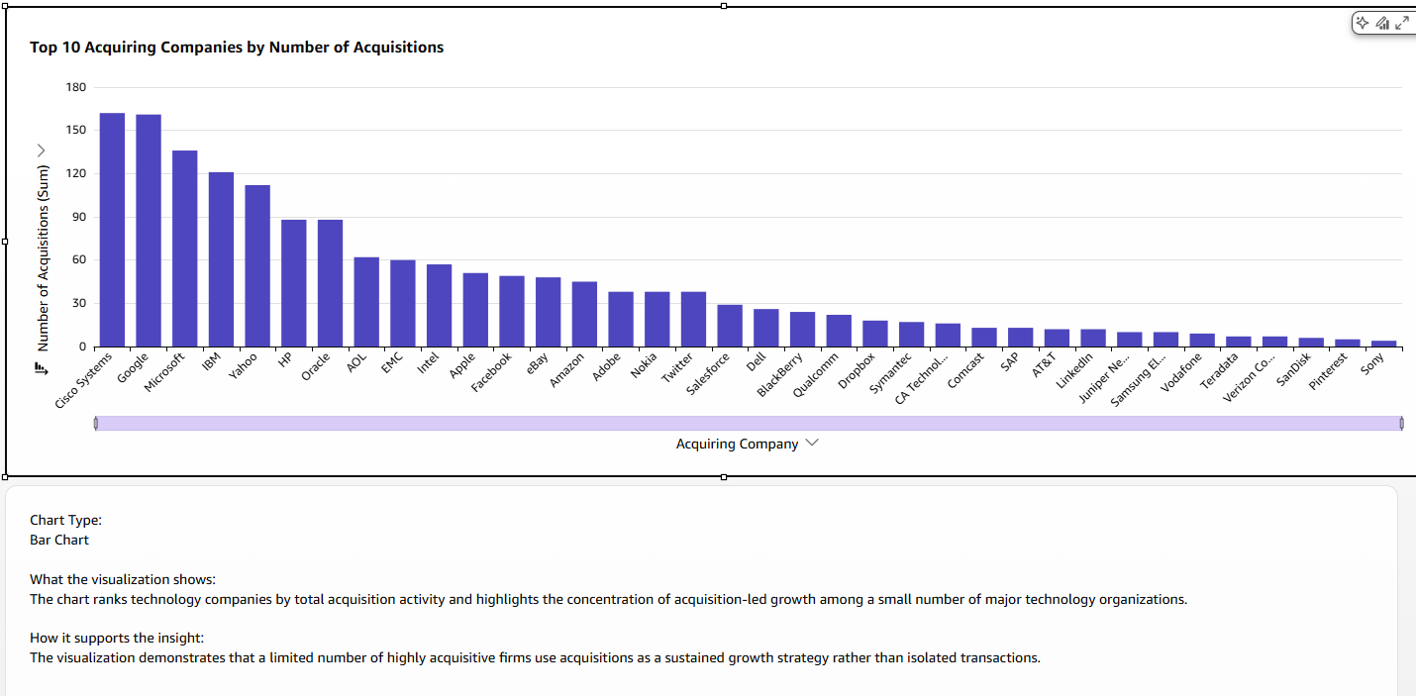

6. Confidence Assessment
Insight | Source Quality | Consistency | Timeliness | Confidence
Capability Acquisition | High | High | Medium | High
Acquisition-Led Growth | High | High | Medium | High
Governance Impact | Medium | High | Medium | Medium
Cloud & Cybersecurity | High | High | High | High
Organizational Alignment | Medium | High | High | Medium

7. Limitations and Risks
Limitation 1
The dataset focuses primarily on technology-sector organizations and may not reflect acquisition behavior in other industries.
Limitation 2
The dataset provides transaction and company characteristics but does not directly measure post-merger integration outcomes.
Limitation 3
External research sources may reflect differing definitions of acquisition success across studies.
Limitation 4
Board composition and founder involvement do not by themselves establish causal relationships with acquisition success.

8. Strategic Implications
Decisions This Research Supports
- M&A technology integration planning
- Due diligence prioritization
- Governance model design
- Cloud modernization strategy
- Acquisition target evaluation

What Should NOT Be Concluded
Caveat 1
The analysis does not prove that higher acquisition volume guarantees better business performance.
Caveat 2
The analysis does not establish direct causation between board composition and successful integration outcomes.
Caveat 3
The findings should not be interpreted as predictions of future acquisition performance.

9. Summary for Leadership
Analysis of technology acquisition activity, acquiring company characteristics, governance structures, and external market research reveals that technology acquisitions are increasingly used to acquire strategic capabilities rather than simply expand market share. The most active acquirers demonstrate acquisition-led innovation models supported by strong governance and executive involvement. External research consistently identifies cloud modernization, cybersecurity readiness, and data integration as leading priorities during post-merger integration. Leadership alignment and governance maturity appear as important as technical execution in determining long-term success. Confidence in the findings is medium-to-high because multiple external research sources align with observed acquisition patterns. Organizations pursuing growth through acquisition should prioritize integration governance, cybersecurity due diligence, and cloud operating model alignment early in the transaction lifecycle. These findings can help leaders improve acquisition planning, accelerate value realization, and reduce integration risk.

